Peter’s Stroll Competitors Guide
V1.0

Overview
The route is based on an LDWA event ‘Peakers Stroll’ that my dear friend James Hobson told me about. I found the route maps online and the route looked brilliant, although it was just a little too short to be a grand day out, so I stole the best bits and added a bit more on to make it a 50k ultra route.
The route starts and ends at Peak Forest, we have booked to village hall to use for a base for the start. The actual event will start 100 metres away on the minor road, just next to the Chapel.
The route skirts around the side of Eldon Hill, across and up to Mam Tor, along the great ridge to the top of Lose Hill, down, then up again to Win Hill, down and across the Ladybower dam, along to the old village of Derwent, through Fairholmes visitor centre, up to Lockerbrook, down to Rowlee farm and Rowlee Bridge, climbing up to Hope Cross, down Jaggers Clough to Edale youth hostel and then Edale village itself, over Rushup edge to Castleton, up the dreaded Cavedale via the Cider Lolly shop, a quick detour to the Trig Point on Bradwell moor and then dropping back down to Peak Forest. The route ends at the Chapel that was the start point.
If you follow the marked route its 50k.
Logistics.
The rather grandly named ‘Race HQ’ will be at the reading room in Peak Forest. Those of you who have run the Bullock Smithy will recognise this as a checkpoint.
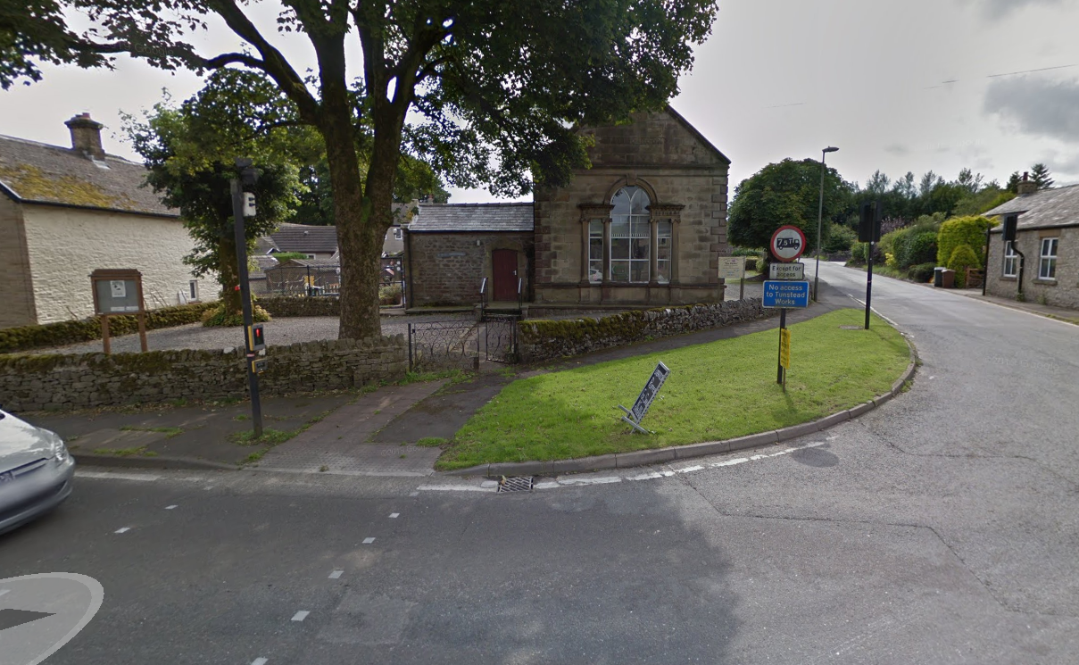
The extensive set of facilities available there will include toilets and drinking water
And err…
Toilets
The ethos of the race is very much about self-sufficiency.
Having said that, you are never very far from a tarmacked road and the route has been planned to include some public waterpoints, cafes, snack bars and shops BUT
There will be
- no staffed checkpoints,
- no race provided food or drink and
- no provision for getting you home if you get injured or tired part way round.

The first place that you can get tap water is nearly 20k into the route. Factor this into your planning if it’s a warm day please!

FRA full kit needs to be carried.
In case you don’t know that’s
Waterproof whole body cover (with taped seams and integrated attached hood)
Hat
Gloves
Map of the route
Compass
Whistle
Emergency food.

The Google Maps logistics map shows you where you can find facilities. You can also share this map with friends and family so that they know where to collect your broken body can plan places to visit and cheer you on, on the day. You can link to a zoomable version of the map here
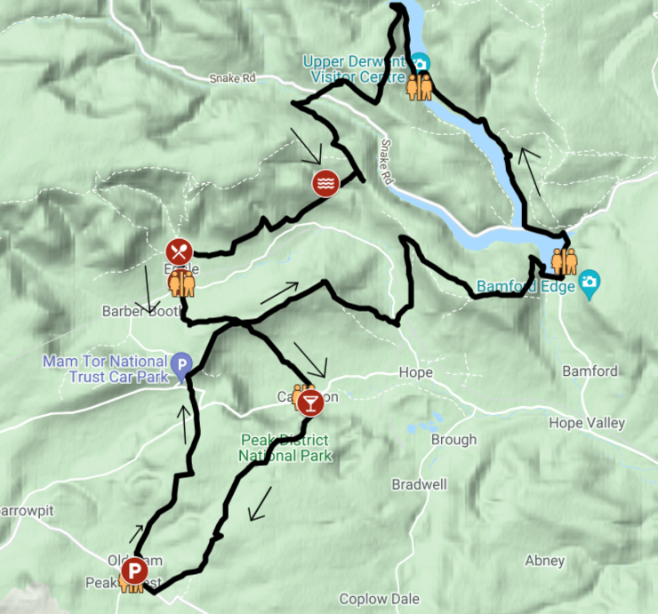

The route.
The route is included in the ordnance survey map extract or the GPX file that is available here
It is a route that must be followed, If you cut off corners then you will come in short of the 50k which will lead to a DNF and lack of championship points.
In particular;

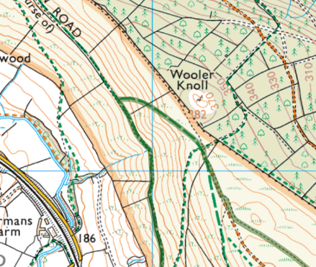
- On the path up from Hope up towards Win Hill you need to follow the bridleway that cuts back from the main path, make sure you have passed the wall before you double back.

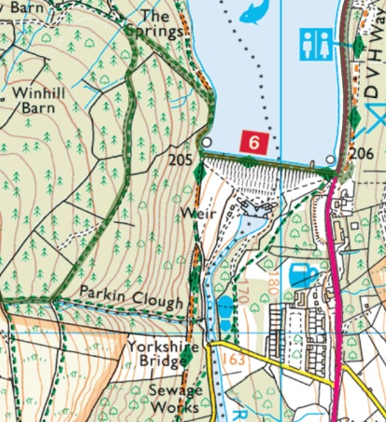
- On the way off Win Hill the full descent down Parkin Clough is not permitted. Those of you who know Parkin Clough will thank me for this.

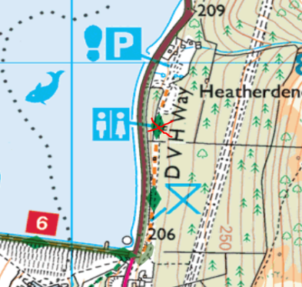
- The public loos and water fountain are on the orange permissive path to the east of the main road, Access is via a set of steps opposite the dam. It’s much nicer that the main road. Feel free to visit!

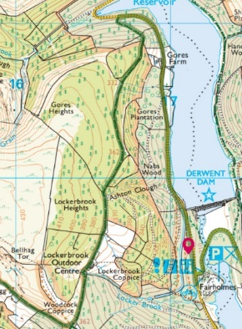
- The route from Fairholmes visitor centre up to Lockerbrook and woodcock (snicker!) is also mandated. Short cuts are not allowed!

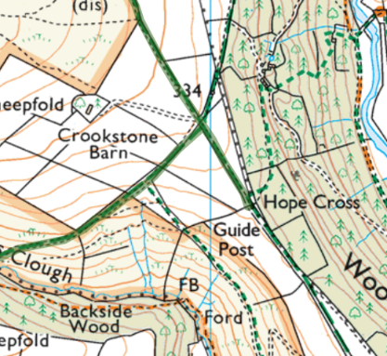
- You will need to do a short ‘out and back’ to the guidepost at Hope Cross. A comedy photo will be a nice way to commemorate this historic landmark.

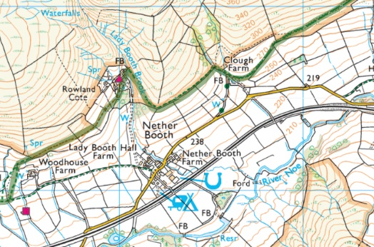
- You need to visit Edale Youth hostel. Be careful not to drop down to the road. It’s a long way up the drive if you do.

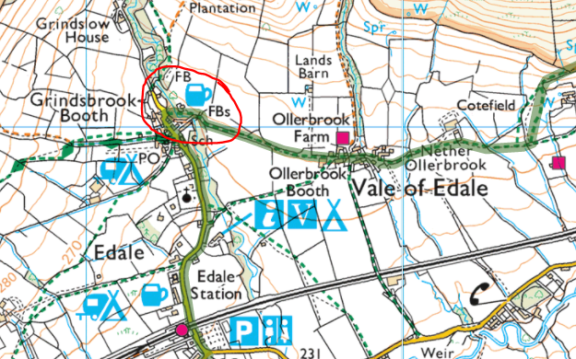
- You need to go past (or visit) the Nags Head at Edale. It’s the start (or end) of the Pennine Way. It’s a place of legends. You can have a pint if you want!

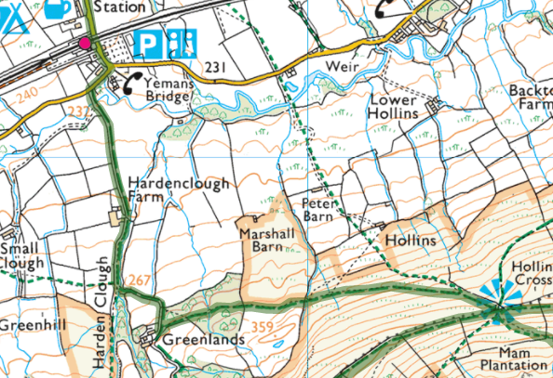
- The route from Edale to Hollins Cross is NOT the Bullock Smithy route. Instead, it goes up Hardens Clough and then across the rising traverse of the bridleway.

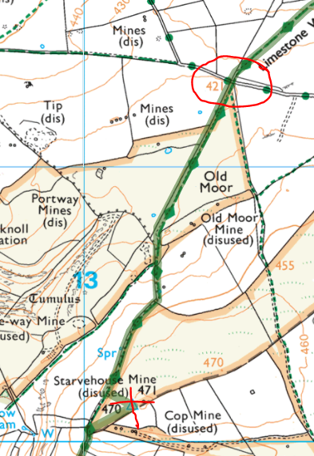
- You need to visit the trig point marked with an X on this map section. Its unusual, a photo will prove you went there. How you get there from the 5 ways junction (circled) is up to you.

Rules
- Mass Start is at 08:30 prompt.
- Enjoy yourselves
- Don’t be an Arse.

Route Map

